Austin Adams Lab 3 Report CS 445

TASK 1:

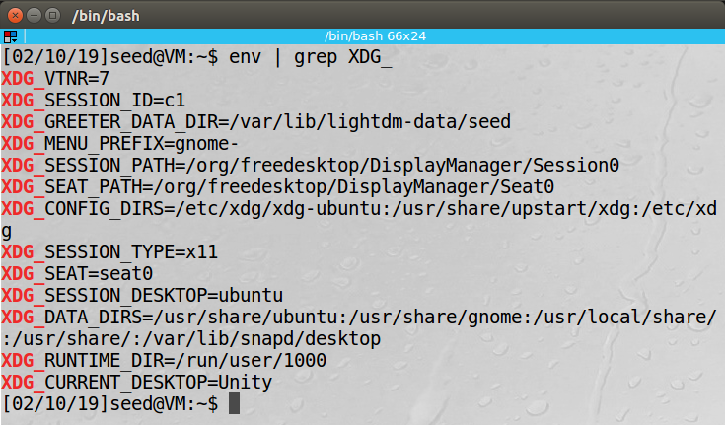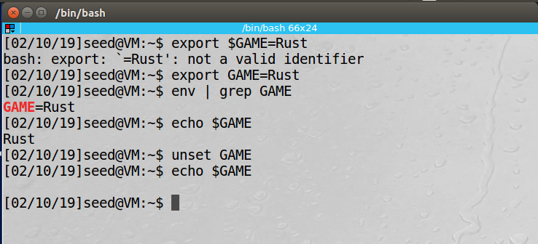

TASK 2:

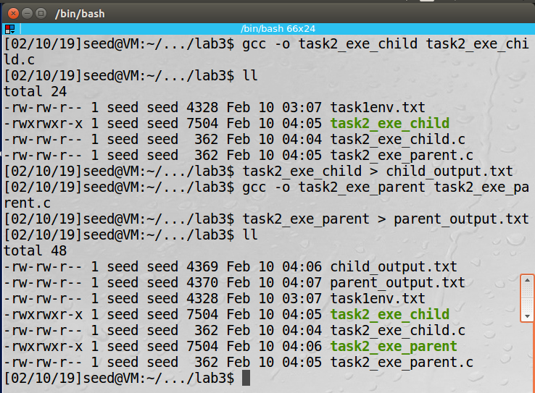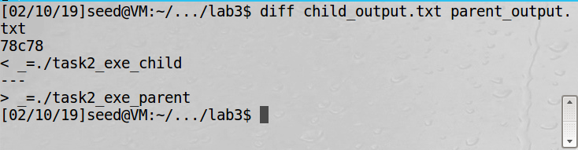

Source file located in /tasks/task2

Since the child process grabs the environment variables from the parent all environment variables should be the same. For me the name of the executable were different only because I named to show whether it was the parent or child variables.

TASK 3:

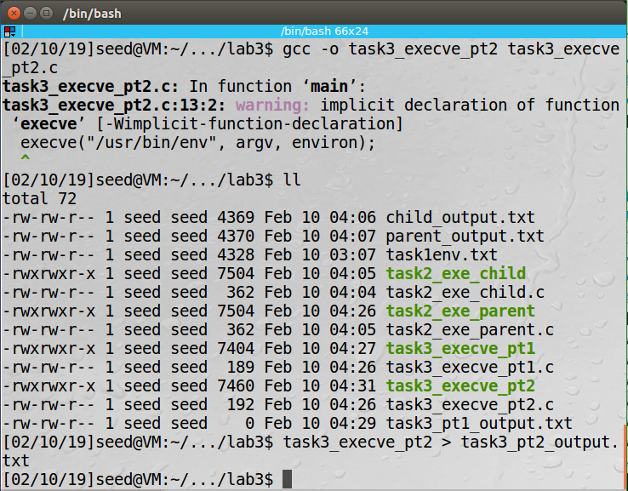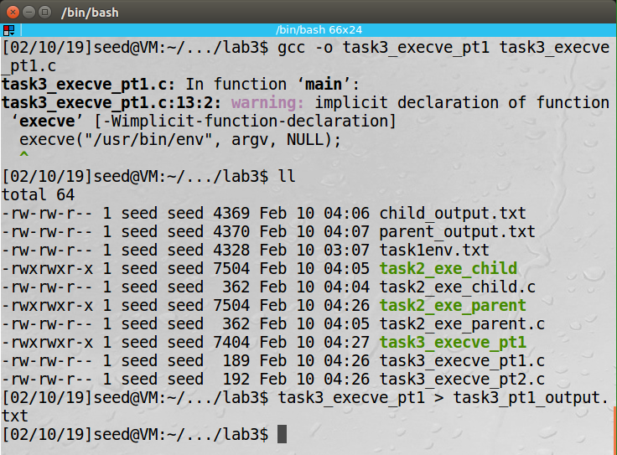

Source file located in /tasks/task3

In task 3 step 1 the environment variables that are given to the child process are NULL. This means that when the execve runs there will be no environment variables. The task3_pt1_ouput.txt shows this. Then in step 2 the execve will now grab the environment variable and pass them to the child process shown by task3_pt2_output.txt

TASK 4:

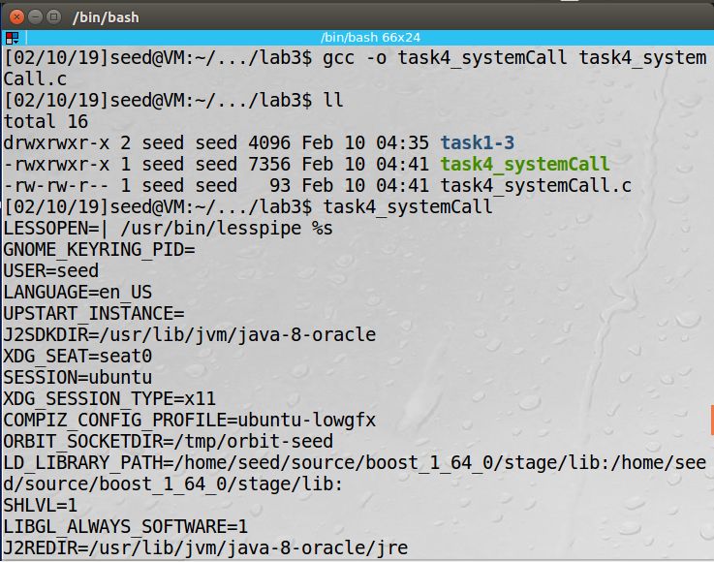

Source file located in /tasks/task4

TASK 5:

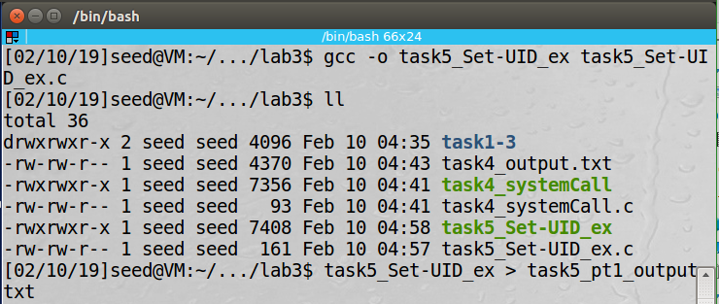

Task 5 part 1

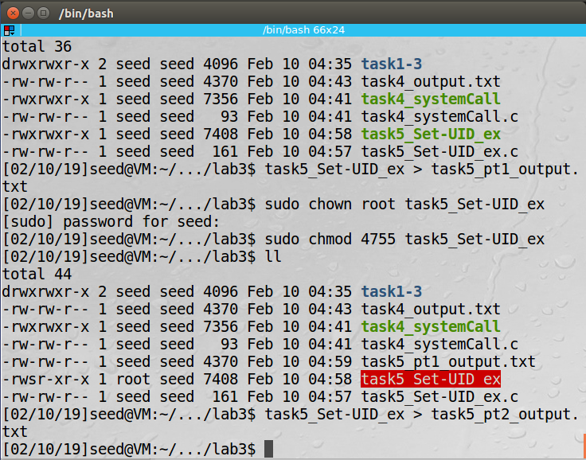

Task 5 part 2

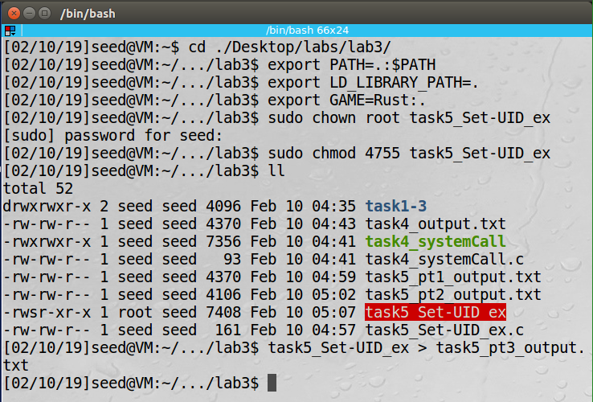

Task 5 part 3

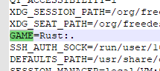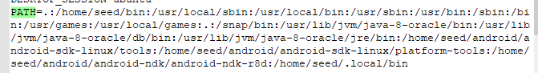

The PATH and my custom environment variable were passed to the child process however Set-UID programs in the /bin/bash do not pass the any LD_* environment variables.

Source file located in /tasks/task5

TASK 6:

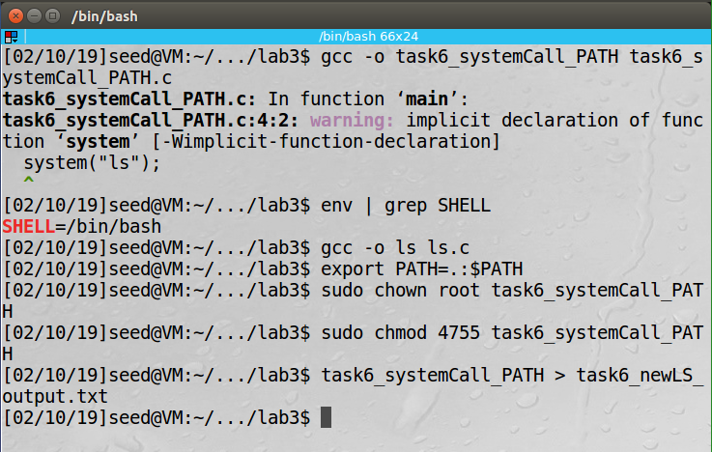

When I run these commands I got an unexpected result. For both normal and Set-UID program I got the expected results to output (task6_normal_output.txt and task6_Set-UID_output.txt), however when I changed the PATH to my current directory and complied my ls.c file I expected to get the same result but instead I got this (task6_newLS_output.txt). I check the shell that the process was running in and it was the /bin/bash then when I removed my own ls function the correct ls function displayed.

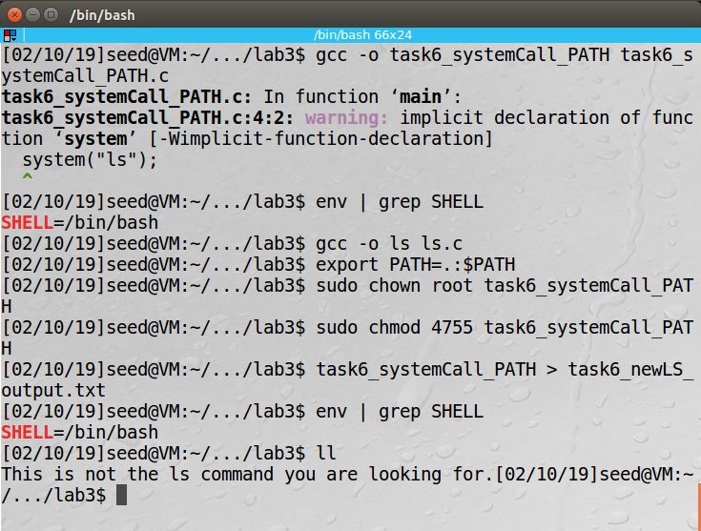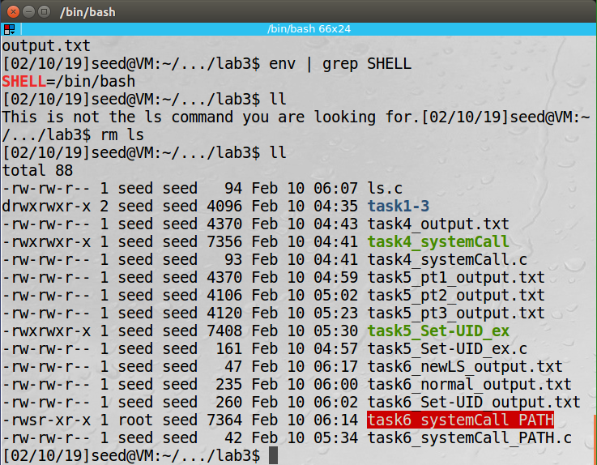

I then changed shells to see if I would get the same results and I did once I changed the PATH and complied the ls.c file my code would run instead.

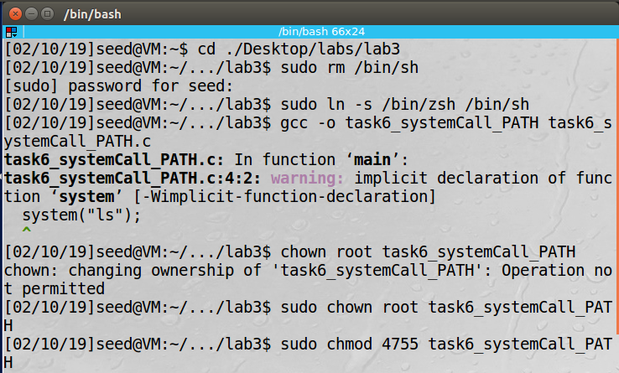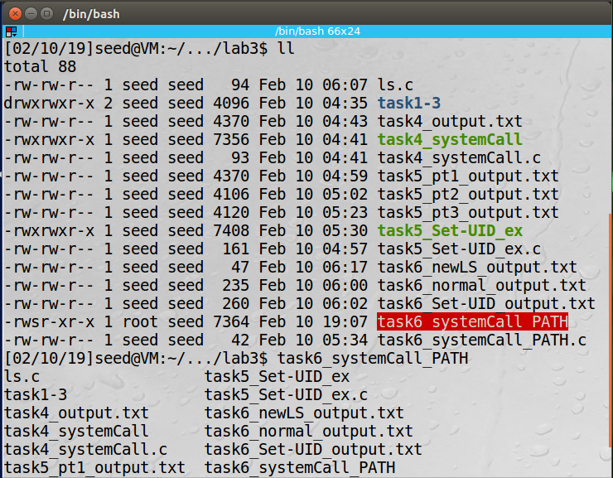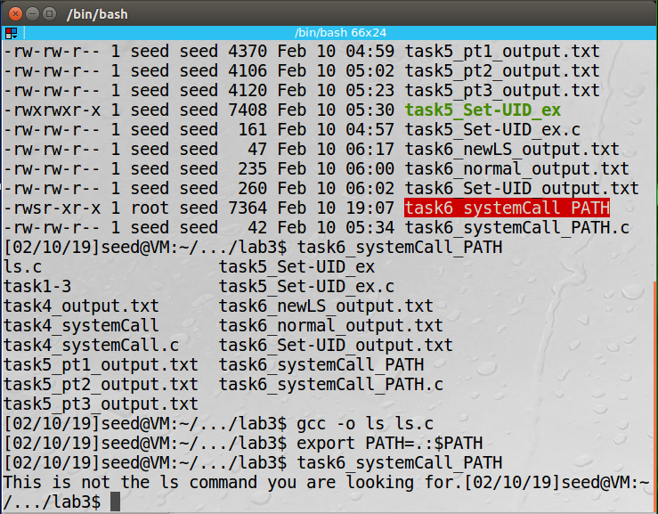

Source file located in /tasks/task6

TASK 7:

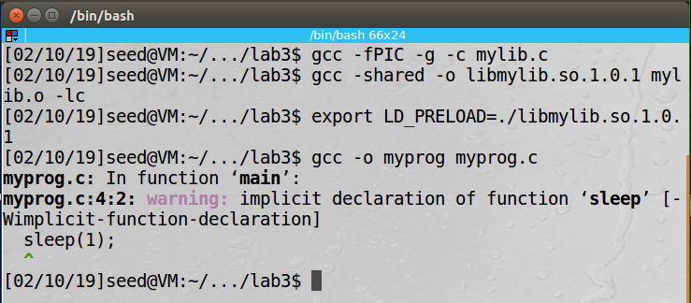

Task 7 step 1

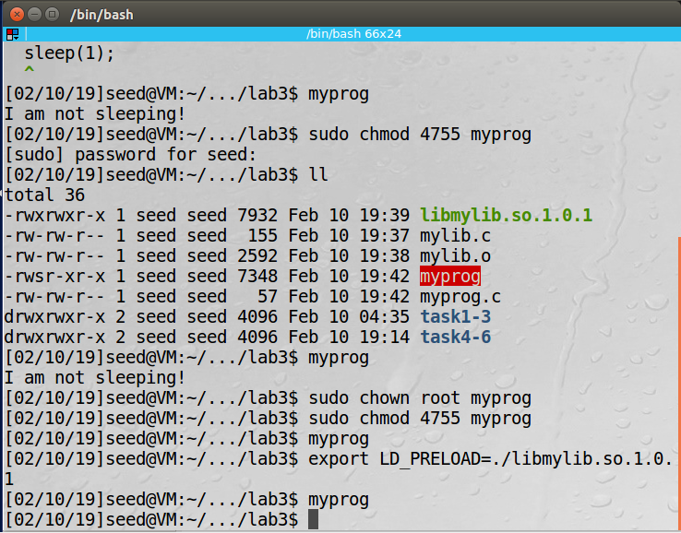

Task 7 step 2

Running as a normal user are regular program allowed my code to run shown. Then I forgot to change the owner to root which still allowed my code to run. Once I changed the owner and Set-UID the correct sleep function ran instead of my code. Even after trying to export the LD_PRELOAD again the correct sleep function ran this is because Set-UID programs owned by the root ignore the LD_* environment variables in this shell as a countermeasure. The same is true when you try to run another users Set-UID program the LD_* variables are ignored.

Source file located in /tasks/task7

TASK 8:

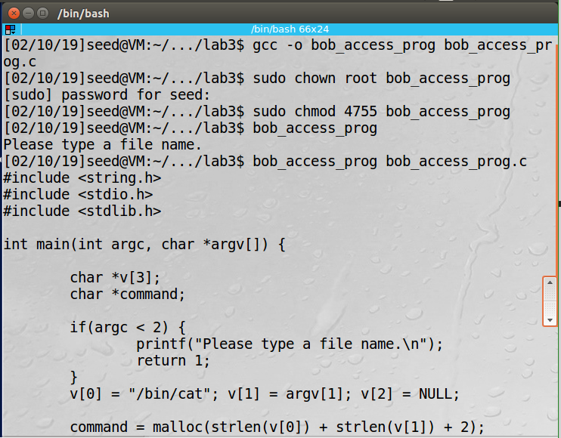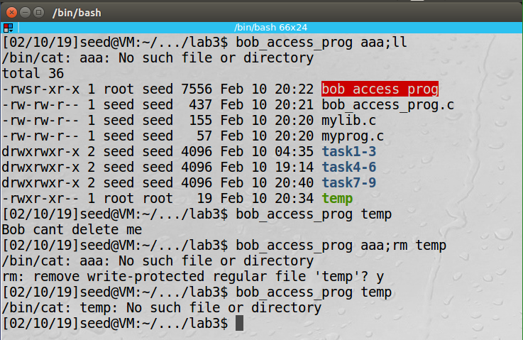

Task 8 step 1 - This was using the system call

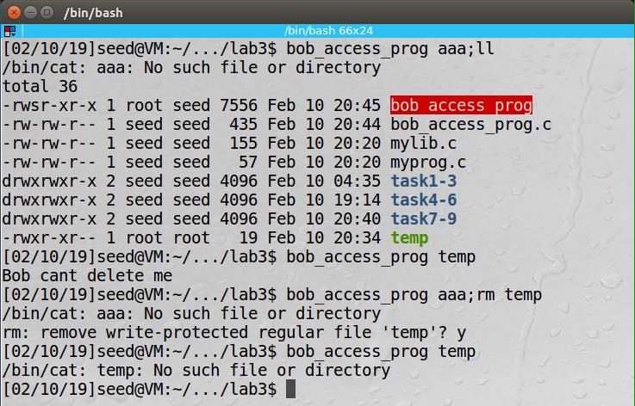

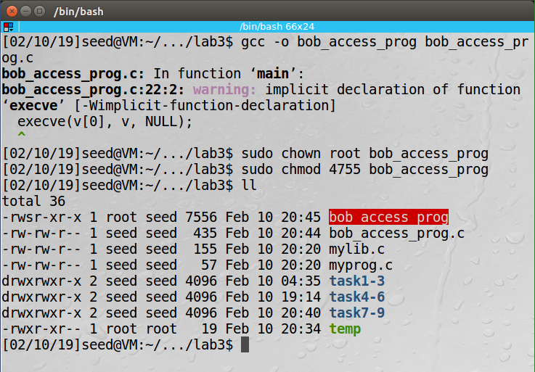

Task 8 part 2 – This was using execve call

In step one I could exploit the system call to run a second command using the semicolon which showed me a file that I can’t write to that is owned by the root. I used the same exploit delete the file. Now using execve I thought that I would not be able to but again I used the same exploit to look at all files and delete a root owned file.

Source file located in /tasks/task8

TASK 9:

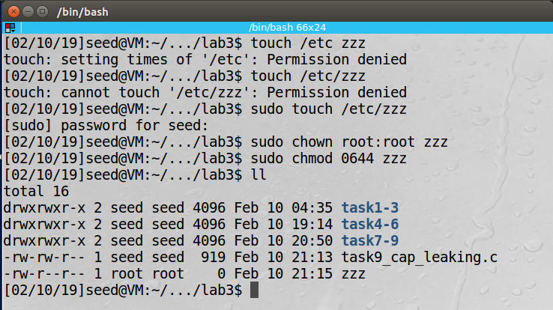

Creating the zzz file with correct permissions

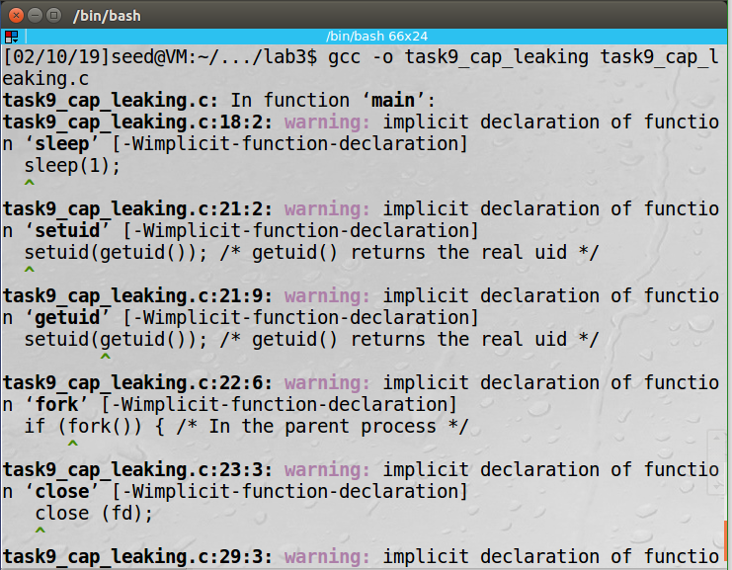

Complied program

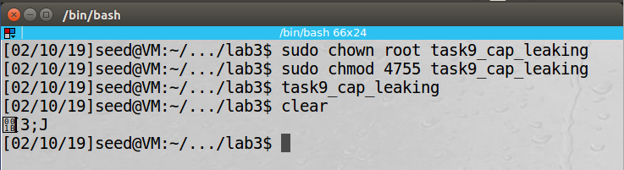

Change owner and make Set-UID then run the program. When the program runs it sleeps for a second then it sets the uid to the real uid then if it’s a then parent process the program exits. If it’s a child process then “Malicious Data” would have been added to zzz but after checking the zzz file was still empty.

Source file located in /tasks/task9